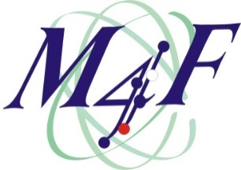 | 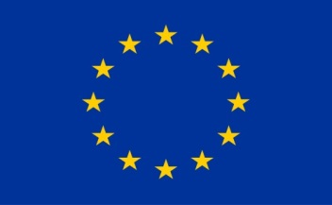

Multiscale Modelling for Fusion and Fission Materials
Project acronym: M4F
H2020 EURATOM WP 2014-2018
Grant Agreement: 755039

Programme of M4F Final Workshop
CIEMAT, Madrid, Spain
25-26 November 2021

Hybrid online and in-person workshop:
25 November: only afternoon 13:30-18:00
26 November: only morning 9:00-13:00

OBJECTIVES
Close to the end of the M4F project, technical talks will report on its main achievements across work-packages, despite the difficulties brought by the Covid19 pandemic to the continuity of the work. The impact of the project so far will be highlighted in keynote talks. The global picture will be provided by suitable introduction and closing remarks by the Euratom officer.

WORKSHOP PROGRAMME
DAY 1 – Thursday 25TH November 2021 – 13:30-18:00

Introduction – Chair: M. Serrano
13:30-13:40 | Welcome and connection time for online participants – M. Serrano
13:40-14:00 | Main goals and achievements of the M4F project | L. Malerba, CIEMAT – M4F Coordinator
14:00-14:15 | Highlights of Domain 1 – Irradiated Microstructure | P. Olsson, KTH, DM leader
14:15-14:30 | Highlights of Domain 2 – Plastic Deformation | E. Gaganidze, KIT, DM leader
14:30-14:40 | Break
Keynote talks – Chair: L. Malerba
14:40-15:20 | Advances on plastic flow localisation in connection with design rules for F/M steels | J. Aktaa, KIT
15:20-16:00 | Good practices for self-ion irradiation for fission and fusion applications: where do we stand? | C. Kaden (Heintze), HZDR, and M.J. Caturla, UA
16:00-16:15 | Break
Technical talks- Chair: M.J. Caturla
16:15-16:45 | Advanced microstructure evolution models: application to Fe alloys under neutron and ion irradiation | N. Castin, SCK CEN
16:45-17:15 | Atom probe studies of neutron and ion irradiated F/M alloys | C. Pareige, GPM/CNRS
17:15-17:45 | Rationalization of experimental observation in irradiated F/M alloys in the light of microstructure evolution models | M. Konstantinović, SCK CEN
17:45-18:00 | Discussion time and closure of first day

WORKSHOP PROGRAMME
DAY 2 – Friday 26TH November 2021 – 9:00-13:00

Technical talks (continued) – Chair: E. Gaganidze
9:00-9:10 | Welcome and connection time for online participants
9:10-9:40 | Nanoindentation for mechanical property assessment of ion-irradiated ferrous alloys | P. Hähner, EC/DG-JRC
9:40-10:10 | Test protocols to fingerprint and quantify irradiation damage using nanoindentation measurement of plasticity size effects | N. Jennett, U. Coventry
10:10-10:40 | Contribution of DFT and atomistic models to the understanding of deformation processes under irradiation in F/M alloys | G. Bonny, SCK CEN
10:40-11:00 | Break
Technical talks (continued) – Chair: P. Olsson
11:00-11:30 | Dislocation dynamics: rationalisation of shear band formation through models | C. Robertson, CEA
11:30-12:00 | Homogenization: mean field versus full field models and comparison with experiments | D. Gonçalves, CEA, and I. Simonovski, EC/DG-JRC
12:00-12:30 | Deformation and Damage behaviour modelling, input from experiments and results | R. Rajakrishnan, KIT
12:30-12:45 | Closing remarks from the Euratom officer | M. Dzubinsky, EC/DG-RTD
12:45-13:00 | Closure of the meeting | L. Malerba

L. Malerba et al. (2021). Multiscale modelling for fusion and fission materials: the M4F project. Nuclear Materials and Energy (2021) 101051. https://doi.org/10.1016/j.nme.2021.101051

